Bookdown test

subtitle goes here

Jack Dougherty

and contributors

2019-07-13

# About the book

This is a test book

**License**

This work is licensed under a Creative Commons Attribution-NonCommercial-ShareAlike 4.0 International License.

**How to cite**: insert here

All text and code for this book is available on [GitHub](https://github.com/jackdougherty/bookdown-test). This work is licensed under a Creative Commons Attribution-NonCommercial-ShareAlike 4.0 International License.

# Chapter 1 with interactive media tests

Testing…

#### Display interactive content in HTML with screenshot in PDF

* First, define a text reference for each caption, because it accepts RMarkdown cites and links. See [Bookdown section 2.2.4](https://bookdown.org/yihui/bookdown/markdown-extensions-by-bookdown.html)
* Second, insert the figure with an R code chunk <https://bookdown.org/yihui/bookdown/r-code.html>, using the if-then-else statement from Michael Dorman, to display interactive version in HTML and static version in PDF.
* Optional: In the body text, insert a dynamic reference to the figure in the same file (which due to floating images in PDF engines, may appear on a different page), like this: … as shown in Figure 1.

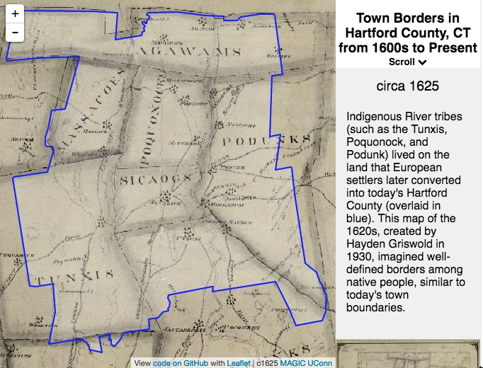

Figure 1: Scroll down the narrative (or click and use arrow keys) in this [interactive map](https://ontheline.github.io/otl-town-borders/) to see how Hartford County, Connecticut was divided into 29 separate towns from the early 1600s to the late 1800s. Boundaries shown here are not exact, but approximated from the best available digital sources: UConn Libraries MAGIC historical maps, Atlas of Historical County Boundaries at Newberry Library, and the Connecticut State Register and Manual. View [map historical sources, known issues, and the code](https://github.com/ontheline/otl-town-borders/), developed by Ilya Ilyankou and Jack Dougherty.[1]

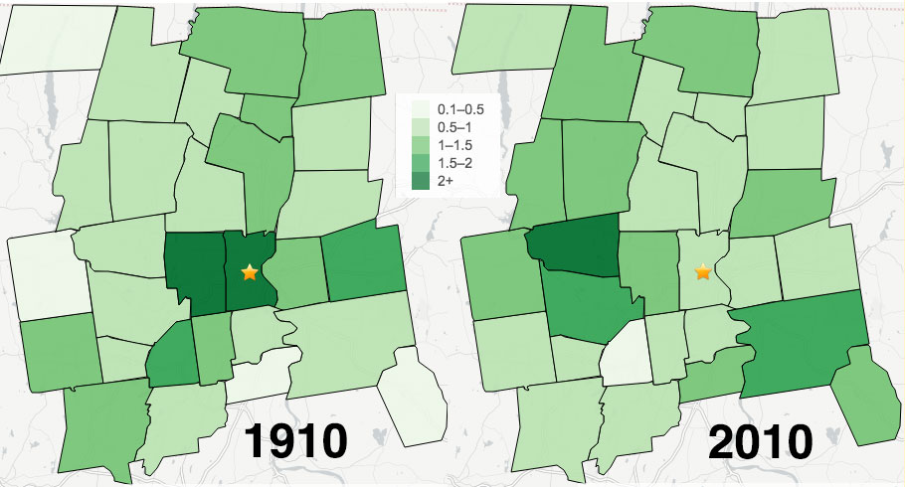

Figure 2: Here’s a sample caption for a second type of interactive map

UPDATED Unanswered questions:

1. What’s the best way to control the image size in PDF output?

* fig.height=9 (default is 7)
* fig_height=9 (I tried both of these versions)
* out.height=“600px”
* out.height=“150%”

1. Is auto.pdf=TRUE necessary? How about out.width="100%"?
2. What’s the best way to insert an imperative title in interactive maps, charts, scrolling PDFs? (Example: Scroll the Map).

* Cannot insert a title in R chunk to appear immediately above the map, which I tried
* Consider adding HTML title directly above digital element in GitHub repo, but separate from bookdown
* Consider adding bold title at beginning of caption: **Image 3.3 Scroll the Map**.

1. To do later: modify style.css p.caption for PDF to make underscored links visible in captions, to allow easy click to HTML version

TESTING VIDEO IN BOOKDOWN:

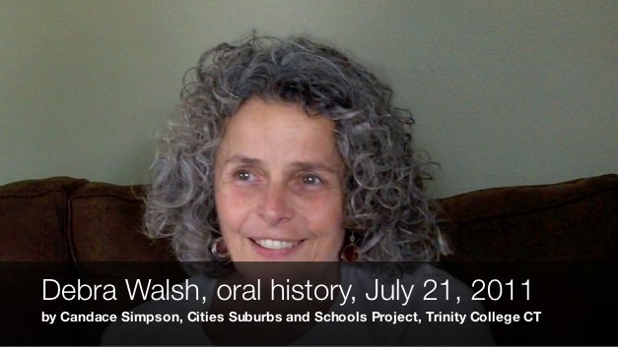

Figure 3: Here’s a sample Vimeo caption, with option to add Markdown link and footnote.

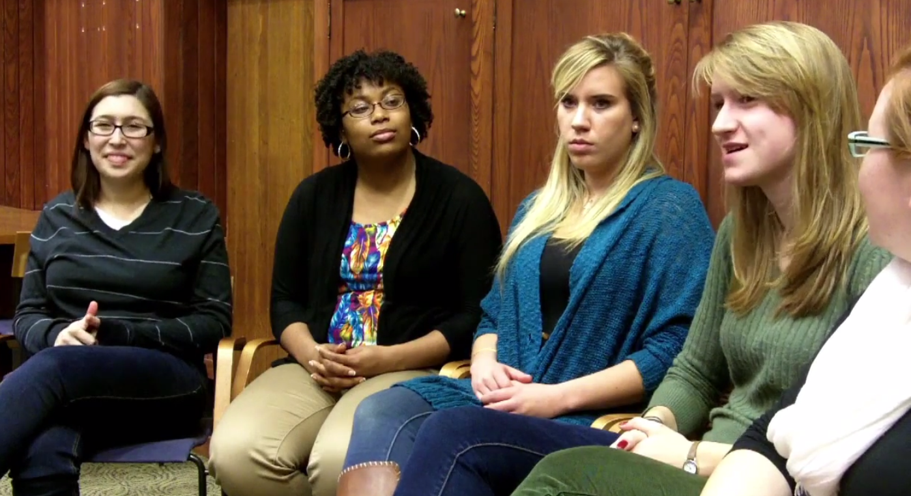

Figure 4: Here’s a sample YouTube caption, with option to add Markdown link and footnote.

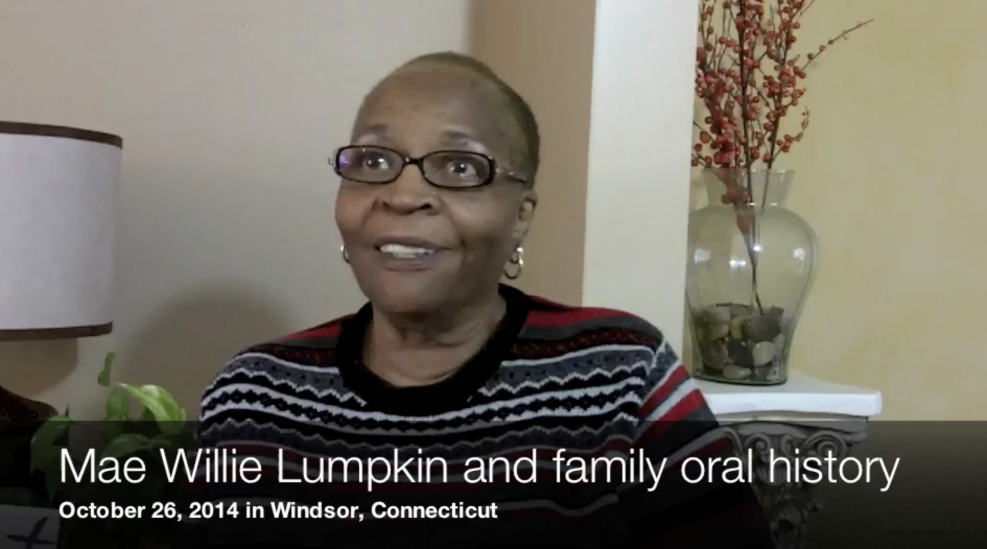

Figure 5: Here’s a sample CTDA video caption, with option to add Markdown link and footnote.

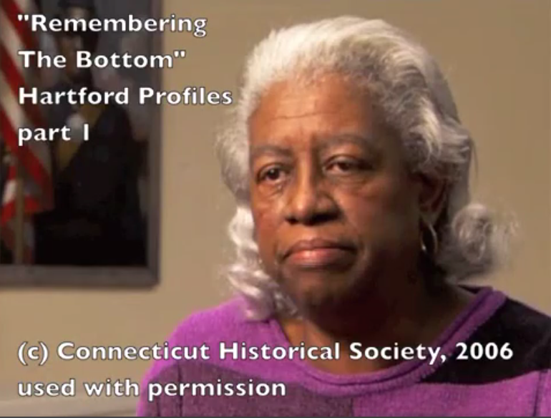

Figure 6: Here’s a sample Kaltura video caption, with option to add Markdown link and footnote.

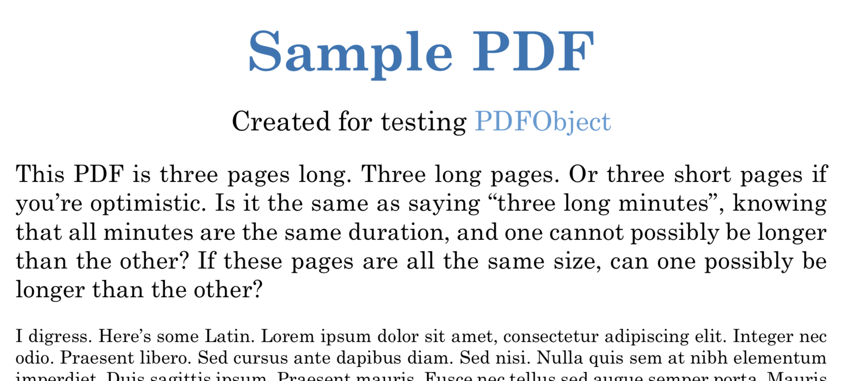

Figure 7: Here’s a sample local scrollable PDF caption, with option to add Markdown link and footnote.

References:

* R Markdown book section on figures <https://bookdown.org/yihui/rmarkdown/html-document.html#figure-options>
* R Markdown reference <https://www.rstudio.com/wp-content/uploads/2015/03/rmarkdown-reference.pdf>
* On R code chunks in RMarkdown <https://bookdown.org/yihui/rmarkdown/r-code.html>
* On R code options in knitr package <https://yihui.name/knitr/options>
* Tips and tricks <http://zevross.com/blog/2017/06/19/tips-and-tricks-for-working-with-images-and-figures-in-r-markdown-documents/#arguments-out.width-and-out.height-apply-to-both-existing-images-and-r-generated-figures>

# Chapter 2

Lorem ipsum dolor sit amet, consectetur adipisicing elit, sed do eiusmod tempor incididunt ut labore et dolore magna aliqua. Ut enim ad minim veniam, quis nostrud exercitation ullamco laboris nisi ut aliquip ex ea commodo consequat. Duis aute irure dolor in reprehenderit in voluptate velit esse cillum dolore eu fugiat nulla pariatur. Excepteur sint occaecat cupidatat non proident, sunt in culpa qui officia deserunt mollit anim id est laborum.[2]

Lorem ipsum dolor sit amet, consectetur adipisicing elit, sed do eiusmod tempor incididunt ut labore et dolore magna aliqua. Ut enim ad minim veniam, quis nostrud exercitation ullamco laboris nisi ut aliquip ex ea commodo consequat. Duis aute irure dolor in reprehenderit in voluptate velit esse cillum dolore eu fugiat nulla pariatur. Excepteur sint occaecat cupidatat non proident, sunt in culpa qui officia deserunt mollit anim id est laborum.[3]

Lorem ipsum dolor sit amet, consectetur adipisicing elit, sed do eiusmod tempor incididunt ut labore et dolore magna aliqua. Ut enim ad minim veniam, quis nostrud exercitation ullamco laboris nisi ut aliquip ex ea commodo consequat. Duis aute irure dolor in reprehenderit in voluptate velit esse cillum dolore eu fugiat nulla pariatur. Excepteur sint occaecat cupidatat non proident, sunt in culpa qui officia deserunt mollit anim id est laborum.[4]

Lorem ipsum dolor sit amet, consectetur adipisicing elit, sed do eiusmod tempor incididunt ut labore et dolore magna aliqua. Ut enim ad minim veniam, quis nostrud exercitation ullamco laboris nisi ut aliquip ex ea commodo consequat. Duis aute irure dolor in reprehenderit in voluptate velit esse cillum dolore eu fugiat nulla pariatur. Excepteur sint occaecat cupidatat non proident, sunt in culpa qui officia deserunt mollit anim id est laborum. Duis aute irure dolor in reprehenderit in voluptate velit esse cillum dolore eu fugiat nulla pariatur. Excepteur sint occaecat cupidatat non proident, sunt in culpa qui officia deserunt mollit anim id est laborum.[5]

Lorem ipsum dolor sit amet, consectetur adipisicing elit, sed do eiusmod tempor incididunt ut labore et dolore magna aliqua. Ut enim ad minim veniam, quis nostrud exercitation ullamco laboris nisi ut aliquip ex ea commodo consequat. Duis aute irure dolor in reprehenderit in voluptate velit esse cillum dolore eu fugiat nulla pariatur. Excepteur sint occaecat cupidatat non proident, sunt in culpa qui officia deserunt mollit anim id est laborum.[6]

Lorem ipsum dolor sit amet, consectetur adipisicing elit, sed do eiusmod tempor incididunt ut labore et dolore magna aliqua. Ut enim ad minim veniam, quis nostrud exercitation ullamco laboris nisi ut aliquip ex ea commodo consequat. Duis aute irure dolor in reprehenderit in voluptate velit esse cillum dolore eu fugiat nulla pariatur. Excepteur sint occaecat cupidatat non proident, sunt in culpa qui officia deserunt mollit anim id est laborum..[7]

Lorem ipsum dolor sit amet, consectetur adipisicing elit, sed do eiusmod tempor incididunt ut labore et dolore magna aliqua. Ut enim ad minim veniam, quis nostrud exercitation ullamco laboris nisi ut aliquip ex ea commodo consequat. Duis aute irure dolor in reprehenderit in voluptate velit esse cillum dolore eu fugiat nulla pariatur. Excepteur sint occaecat cupidatat non proident, sunt in culpa qui officia deserunt mollit anim id est laborum.Lorem ipsum dolor sit amet, consectetur adipisicing elit, sed do eiusmod tempor incididunt ut labore et dolore magna aliqua. Ut enim ad minim veniam, quis nostrud exercitation ullamco laboris nisi ut aliquip ex ea commodo consequat.[8]

Lorem ipsum dolor sit amet, consectetur adipisicing elit, sed do eiusmod tempor incididunt ut labore et dolore magna aliqua. Ut enim ad minim veniam, quis nostrud exercitation ullamco laboris nisi ut aliquip ex ea commodo consequat. Duis aute irure dolor in reprehenderit in voluptate velit esse cillum dolore eu fugiat nulla pariatur. Excepteur sint occaecat cupidatat non proident, sunt in culpa qui officia deserunt mollit anim id est laborum.[9]

Lorem ipsum dolor sit amet, consectetur adipisicing elit, sed do eiusmod tempor incididunt ut labore et dolore magna aliqua. Ut enim ad minim veniam, quis nostrud exercitation ullamco laboris nisi ut aliquip ex ea commodo consequat. Duis aute irure dolor in reprehenderit in voluptate velit esse cillum dolore eu fugiat nulla pariatur. Excepteur sint occaecat cupidatat non proident, sunt in culpa qui officia deserunt mollit anim id est laborum.[10]

Lorem ipsum dolor sit amet, consectetur adipisicing elit, sed do eiusmod tempor incididunt ut labore et dolore magna aliqua. Ut enim ad minim veniam, quis nostrud exercitation ullamco laboris nisi ut aliquip ex ea commodo consequat. Duis aute irure dolor in reprehenderit in voluptate velit esse cillum dolore eu fugiat nulla pariatur. Excepteur sint occaecat cupidatat non proident, sunt in culpa qui officia deserunt mollit anim id est laborum.[11]

## Subchapter 2.1 for note testing

More text here More text here More text here More text here More text here More text here More text here More text here More text here More text here More text here More text here More text here More text here More text here More text here More text here More text here More text here More text here More text here More text here More text here More text here More text here More text here More text here More text here More text here.[12]

Lorem ipsum dolor sit amet, consectetur adipisicing elit, sed do eiusmod tempor incididunt ut labore et dolore magna aliqua. Ut enim ad minim veniam, quis nostrud exercitation ullamco laboris nisi ut aliquip ex ea commodo consequat. Duis aute irure dolor in reprehenderit in voluptate velit esse cillum dolore eu fugiat nulla pariatur. Excepteur sint occaecat cupidatat non proident, sunt in culpa qui officia deserunt mollit anim id est laborum.[13]

Lorem ipsum dolor sit amet, consectetur adipisicing elit, sed do eiusmod tempor incididunt ut labore et dolore magna aliqua. Ut enim ad minim veniam, quis nostrud exercitation ullamco laboris nisi ut aliquip ex ea commodo consequat. Duis aute irure dolor in reprehenderit in voluptate velit esse cillum dolore eu fugiat nulla pariatur. Excepteur sint occaecat cupidatat non proident, sunt in culpa qui officia deserunt mollit anim id est laborum.[14]

Lorem ipsum dolor sit amet, consectetur adipisicing elit, sed do eiusmod tempor incididunt ut labore et dolore magna aliqua. Ut enim ad minim veniam, quis nostrud exercitation ullamco laboris nisi ut aliquip ex ea commodo consequat. Duis aute irure dolor in reprehenderit in voluptate velit esse cillum dolore eu fugiat nulla pariatur. Excepteur sint occaecat cupidatat non proident, sunt in culpa qui officia deserunt mollit anim id est laborum.[15]

# Chapter 3

Lorem ipsum dolor sit amet, consectetur adipisicing elit, sed do eiusmod tempor incididunt ut labore et dolore magna aliqua. Ut enim ad minim veniam, quis nostrud exercitation ullamco laboris nisi ut aliquip ex ea commodo consequat. Duis aute irure dolor in reprehenderit in voluptate velit esse cillum dolore eu fugiat nulla pariatur. Excepteur sint occaecat cupidatat non proident, sunt in culpa qui officia deserunt mollit anim id est laborum.[16]

Lorem ipsum dolor sit amet, consectetur adipisicing elit, sed do eiusmod tempor incididunt ut labore et dolore magna aliqua. Ut enim ad minim veniam, quis nostrud exercitation ullamco laboris nisi ut aliquip ex ea commodo consequat. Duis aute irure dolor in reprehenderit in voluptate velit esse cillum dolore eu fugiat nulla pariatur. Excepteur sint occaecat cupidatat non proident, sunt in culpa qui officia deserunt mollit anim id est laborum.[17]

added text

# Bibliography

Berends, Mark, Marisa Cannata, and Ellen Goldring, eds. *School Choice and School Improvement*. Cambridge Mass.: Harvard Education Press, 2011. <http://www.hepg.org/hep-home/books/school-choice-and-school-improvement>.

Dougherty, Jack. “Bridging the Gap Between Urban, Suburban, and Educational History.” In *Rethinking the History of American Education*, edited by William Reese and John Rury, 245–59. New York: Palgrave MacMillan Press, 2007. <http://digitalrepository.trincoll.edu/cssp_papers/5/>.

———. “Conflicting Questions: Why Historians and Policymakers Miscommunicate on Urban Education.” In *Clio at the Table: Using History to Inform and Improve Education Policy*, edited by Kenneth Wong and Robert Rothman, 251–62. New York: Peter Lang, 2009. <http://digitalrepository.trincoll.edu/cssp_papers/4/>.

———. “Review of ’Connecticut’s Public Schools: A History, 1650-2000’ by Christopher Collier.” *Connecticut History* 50, no. 1 (2011): 120–22. <http://digitalrepository.trincoll.edu/cssp_papers/41>.

Dougherty, Jack, Jeffrey Harrelson, Laura Maloney, Drew Murphy, Russell Smith, Michael Snow, and Diane Zannoni. “School Choice in Suburbia: Test Scores, Race, and Housing Markets.” *American Journal of Education* 115, no. 4 (August 2009): 523–48. <http://digitalrepository.trincoll.edu/cssp_papers/1>.

Dougherty, Jack, Jesse Wanzer, and Christina Ramsay. “Sheff V. O’Neill: Weak Desegregation Remedies and Strong Disincentives in Connecticut, 1996-2008.” In *From the Courtroom to the Classroom: The Shifting Landscape of School Desegregation*, edited by Claire Smrekar and Ellen Goldring, 103–27. Cambridge, MA: Harvard Education Press, 2009. <http://digitalrepository.trincoll.edu/cssp_papers/3/>.

Ilyankou, Ilya, and Jack Dougherty. “Map: Town Borders in Hartford County, CT from 1600s to Present.” On The Line, 2017. <https://github.com/OnTheLine/otl-town-borders>.

Pennington, Lis, Emily Steele, and Jack Dougherty. “A Political History of School Finance Reform in Metropolitan Hartford, Connecticut, 1945-2005.” American Educational Research Association conference paper, April 2007. <http://digitalrepository.trincoll.edu/cssp_papers/29/>.

Tegeler, Philip, ed. *Finding Common Ground: Coordinating Housing and Education Policy to Promote Integration*. Washington, DC: Poverty & Race Research Action Council, 2011. <http://www.prrac.org/pdf/HousingEducationReport-October2011.pdf>.

Wells, Amy Stuart, Bianca J. Baldridge, J. Duran, C. Grzesikowski, R. Lofton, A. Roda, M. Warner, and T. White. “Boundary Crossing for Diversity, Equity, and Achievement: Interdistrict School Desegregation and Educational Opportunity.” Cambridge MA: Charles Hamilton Houston Institute for Race and Justice, November 2009. <http://charleshamiltonhouston.org/assets/documents/publications/Wells_BoundaryCrossing.pdf>.

Whitten, Robert Harvey. *West Hartford Zoning: Report to the Zoning Commission on the Zoning of West Hartford*. West Hartford, Conn: Zoning Commission, 1924. <http://magic.lib.uconn.edu/magic_2/raster/37840/hdimg_37840_155_1924_unkn_CSL_1_p.pdf>.

1. Ilya Ilyankou and Jack Dougherty, “Map: Town Borders in Hartford County, CT from 1600s to Present,” On The Line, 2017, <https://github.com/OnTheLine/otl-town-borders>
2. Philip Tegeler, ed., *Finding Common Ground: Coordinating Housing and Education Policy to Promote Integration* (Washington, DC: Poverty & Race Research Action Council, 2011), <http://www.prrac.org/pdf/HousingEducationReport-October2011.pdf>.
3. Robert Harvey Whitten, *West Hartford Zoning: Report to the Zoning Commission on the Zoning of West Hartford* (West Hartford, Conn: Zoning Commission, 1924), <http://magic.lib.uconn.edu/magic_2/raster/37840/hdimg_37840_155_1924_unkn_CSL_1_p.pdf>.
4. Lis Pennington, Emily Steele, and Jack Dougherty, “A Political History of School Finance Reform in Metropolitan Hartford, Connecticut, 1945-2005” (American Educational Research Association conference paper, April 2007), <http://digitalrepository.trincoll.edu/cssp_papers/29/>.
5. Jack Dougherty, “Review of ’Connecticut’s Public Schools: A History, 1650-2000’ by Christopher Collier,” *Connecticut History* 50, no. 1 (2011): 120–22, <http://digitalrepository.trincoll.edu/cssp_papers/41>.
6. Jack Dougherty, “Conflicting Questions: Why Historians and Policymakers Miscommunicate on Urban Education,” in *Clio at the Table: Using History to Inform and Improve Education Policy*, ed. Kenneth Wong and Robert Rothman (New York: Peter Lang, 2009), 251–62, <http://digitalrepository.trincoll.edu/cssp_papers/4/>.
7. Jack Dougherty, Jesse Wanzer, and Christina Ramsay, “Sheff V. O’Neill: Weak Desegregation Remedies and Strong Disincentives in Connecticut, 1996-2008,” in *From the Courtroom to the Classroom: The Shifting Landscape of School Desegregation*, ed. Claire Smrekar and Ellen Goldring (Cambridge, MA: Harvard Education Press, 2009), 103–27, <http://digitalrepository.trincoll.edu/cssp_papers/3/>.
8. Jack Dougherty, “Bridging the Gap Between Urban, Suburban, and Educational History,” in *Rethinking the History of American Education*, ed. William Reese and John Rury (New York: Palgrave MacMillan Press, 2007), 245–59, <http://digitalrepository.trincoll.edu/cssp_papers/5/>.
9. Jack Dougherty et al., “School Choice in Suburbia: Test Scores, Race, and Housing Markets,” *American Journal of Education* 115, no. 4 (August 2009): 523–48, <http://digitalrepository.trincoll.edu/cssp_papers/1>.
10. Amy Stuart Wells et al., “Boundary Crossing for Diversity, Equity, and Achievement: Interdistrict School Desegregation and Educational Opportunity” (Cambridge MA: Charles Hamilton Houston Institute for Race and Justice, November 2009), <http://charleshamiltonhouston.org/assets/documents/publications/Wells_BoundaryCrossing.pdf>.
11. Mark Berends, Marisa Cannata, and Ellen Goldring, eds., *School Choice and School Improvement* (Cambridge Mass.: Harvard Education Press, 2011), <http://www.hepg.org/hep-home/books/school-choice-and-school-improvement>.
12. Pennington, Steele, and Dougherty, “A Political History of School Finance Reform in Metropolitan Hartford, Connecticut, 1945-2005.”
13. Dougherty, “Review of ’Connecticut’s Public Schools.”
14. Tegeler, *Finding Common Ground*.
15. Whitten, *West Hartford Zoning*.
16. Tegeler, *Finding Common Ground*.
17. Whitten, *West Hartford Zoning*.